N301-- How to setup Bandwidth Control
Note: This article will guide you how to setup speed control and the steps as below.

Step 1: Connect your computer to the LAN port .Power on the N301.

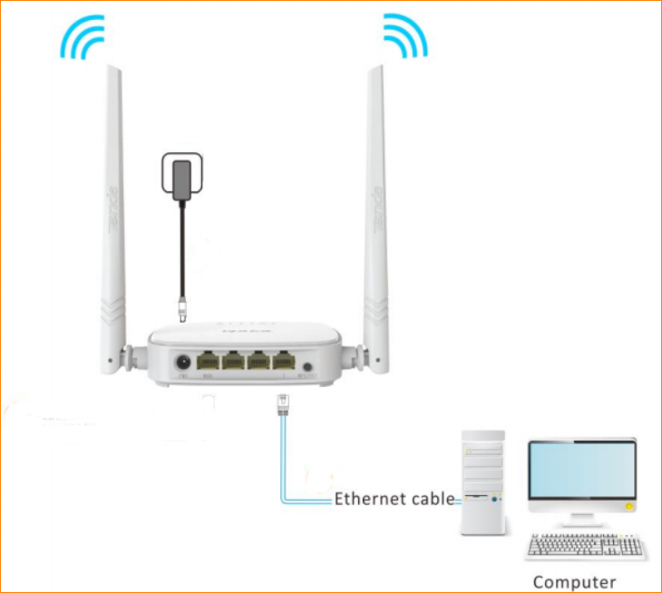

You can also use your smartphone to configure the router.

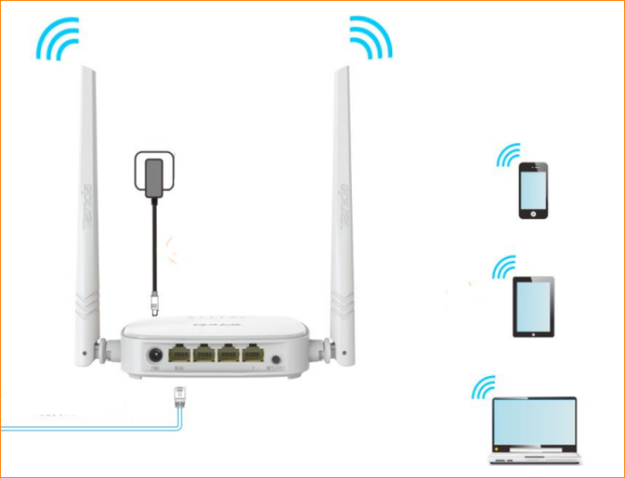

Step 2: Open a Web Browser -> Input 192.168.0.1 in the address bar -> Press Enter



Step 3: Go to Bandwidth Control and choose the device you want to control. Set the speed of upload limit and download limit, then click “OK” to save all the settings.

